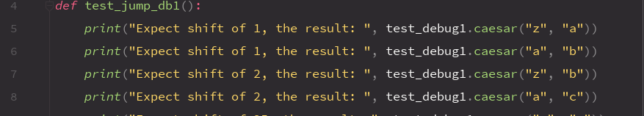



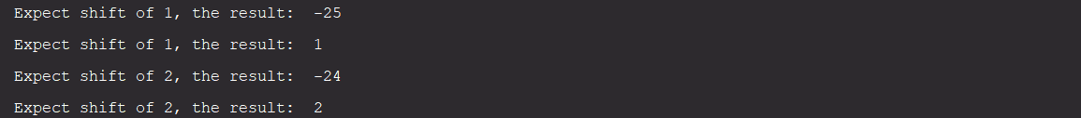

When these tests are run its clear that the valid cypher checker does not account for wrap arounds. To confirm this suspicion we can check the debugger while running the cipher function using the following params: “za”,”ab”. We see 2 flawed yet correct examples when the code is run because there is no wrap around in those 2 tests.





As seen above this confirms my suspicions.

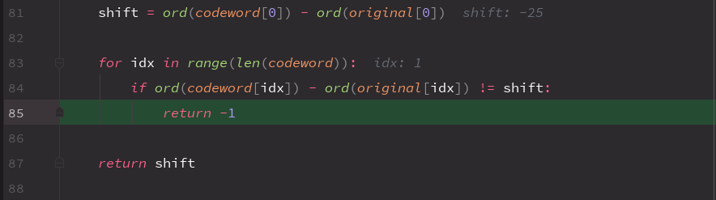

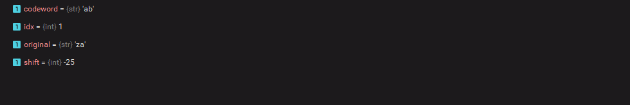

Its clear that as the first shift is a shift of 1 but the program registers it as -25 due to it not taking wrap around into consideration. The following code fixes this issue.

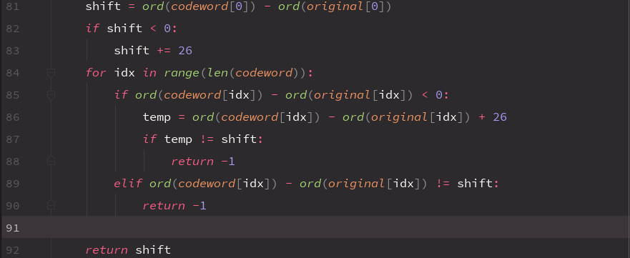

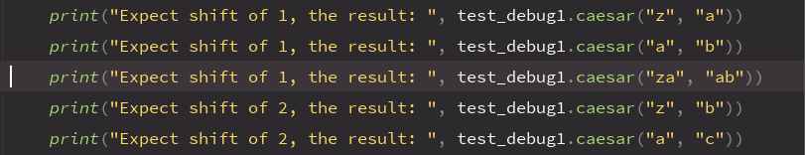

As we can see the wrap-around test is passed.

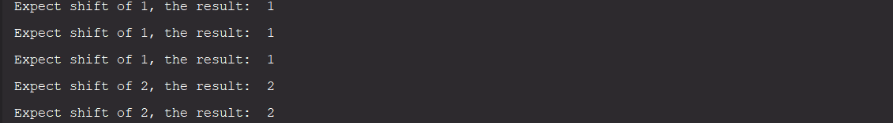

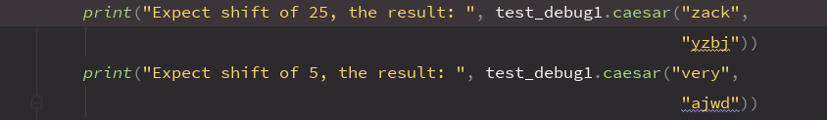

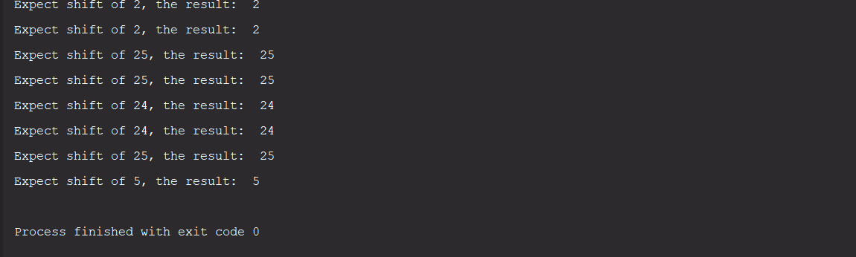

For the first test we notice that the function skips the last letter in each string. 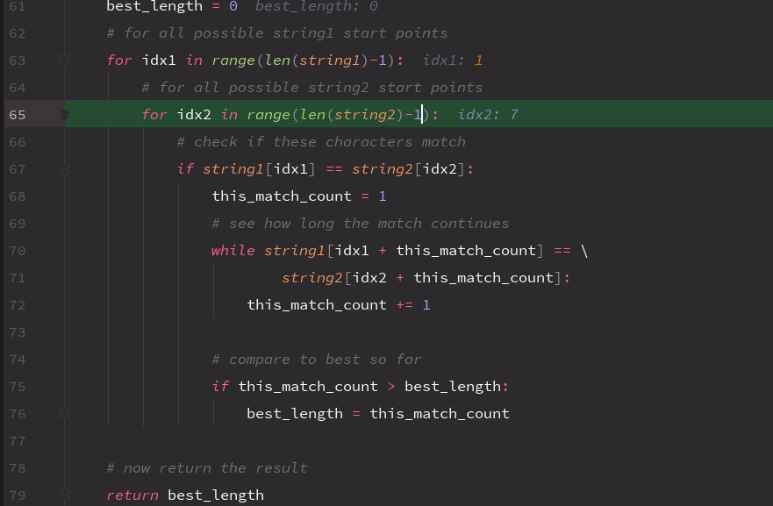

To fix this we can remove -1. This is a logical error where the developer thought the range function is inclusive.

Besides that, in the above screenshot we also notice that the arguments in the while loop can go out of range as they have no loop control condition. To fix this we can introduce a while loop that ensures the check stays within bounds of the shortest string and then another conditional can be used to break out of the loop when the matching pattern ends.

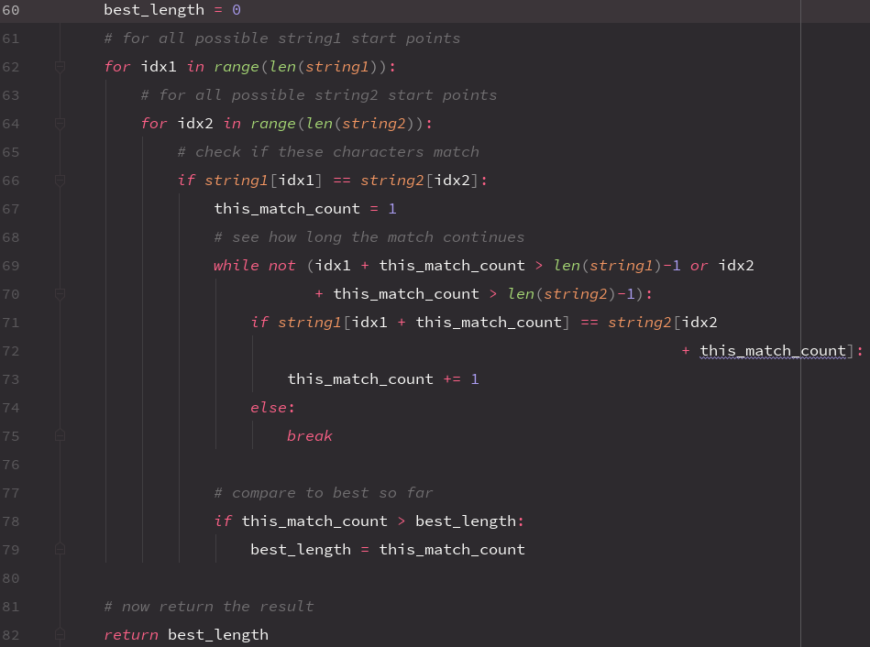

To break out of the loop we can simply use an else statement and break since no match is the only other possibility.

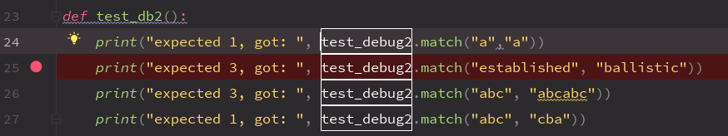

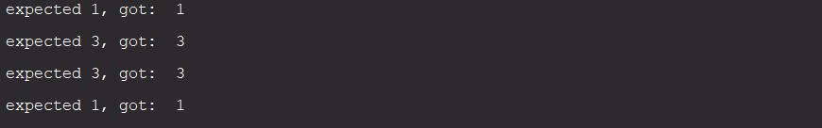

And as we can see the following fixes allow the code to pass our texts.